The City of Ottawa

Shelley McDonald, Director, Solid Waste Services

2023, 10, 03

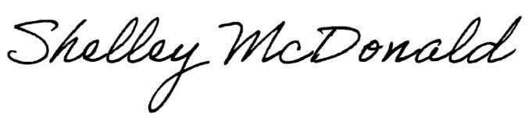< click to edit text >