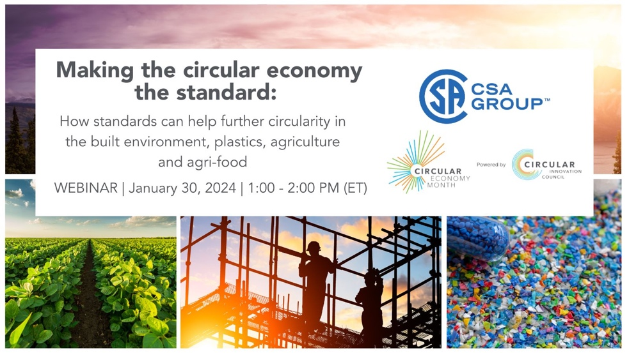

WEBINAR PRE-READ DOCUMENT

The Role of Standards in Transitioning to a Circular Economy
While the principles of the circular economy are the same across all economic sectors, the ‘language’ different industries, governments, and the general public use is not always the same. Standards can help align all parties and guide them as they work together towards the common goal.

Who is the Canadian Standards Association?
The mission of the Canadian Standards Association (CSA), CSA Group’s not-for-profit Standards Development organization, is to enhance the lives of Canadians through the advancement of standards in the public and private sectors. CSA’s research, education, and advocacy activities help disseminate guidance and best practices that support the adoption of circular economy principles across various sectors of Canada’s economy.

What are standards?
Standards are agreed-upon ways of doing things to achieve a common purpose. They are developed by a balanced committee of experts who work to achieve consensus on the minimum requirements of any given standard. That way, standards can help ensure the products, systems, or services we use every day, whether at home, work, or play, operate safely, consistently, and as intended.

How can standards support the transition to circularity?
As governments and industry begin to focus on the adoption of circular practices, standards can provide common definitions of processes, terms and their related outcomes to help ensure outcomes are measured and reported in a consistent, transparent, and verifiable way.

Standards can also provide guidance and best practices for material selection, design of products and systems that are more durable, and consider disassembly, reuse, recycling, and other principles of circularity.

As organizations shift toward circular business practices, the harmonization of standards across regions and internationally can help support business and trade across borders.

What circular standards exist or are being developed in Canada and beyond?
There are many standards and guidelines that support circularity already. CSA has published standards and guidelines for the construction sector since 1995, addressing durability in buildings, design for disassembly and adaptability in buildings, as well as accountable management of end-of-life materials.

In addition, several new national standards are currently under development. These include a new standard for definitions of plastics recycling and exploring opportunities where standards can further support the ecosystem for circularity in construction, agrifood, and agriculture.

CSA has also joined forces with Resolve, an accredited standards development organization in the U.S., to develop a series of new Canada – U.S. binational standards for reusable packaging, addressing container design, third-party washing, sanitization and handling of foodware, labelling, and education.

Lastly, the International Organization for Standardization (ISO) has also established a new, dedicated, Technical Committee focused specifically on developing standards to support further integration of circular practices. New ISO standards under development address:
- the transition of business models and value networks to circularity
- measuring and assessing circularity performance
- review of existing value networks

CSA manages the national committee that provides comments on these draft international standards and helps ensure Canada’s views are heard. CSA will work to adopt these ISO standards as national standards of Canada once published.

For more information, visit CSA Group’s Circular Economy webpage.

CSA Group always strives to provide up-to-date and accurate information. However, no representation or warranty, expressed or implied, is made that this information meets your specific needs, and any reliance on this information is at your own risk. Please contact CSA Group for more information about our services.
© 2024 Canadian Standards Association. All Rights Reserved.

