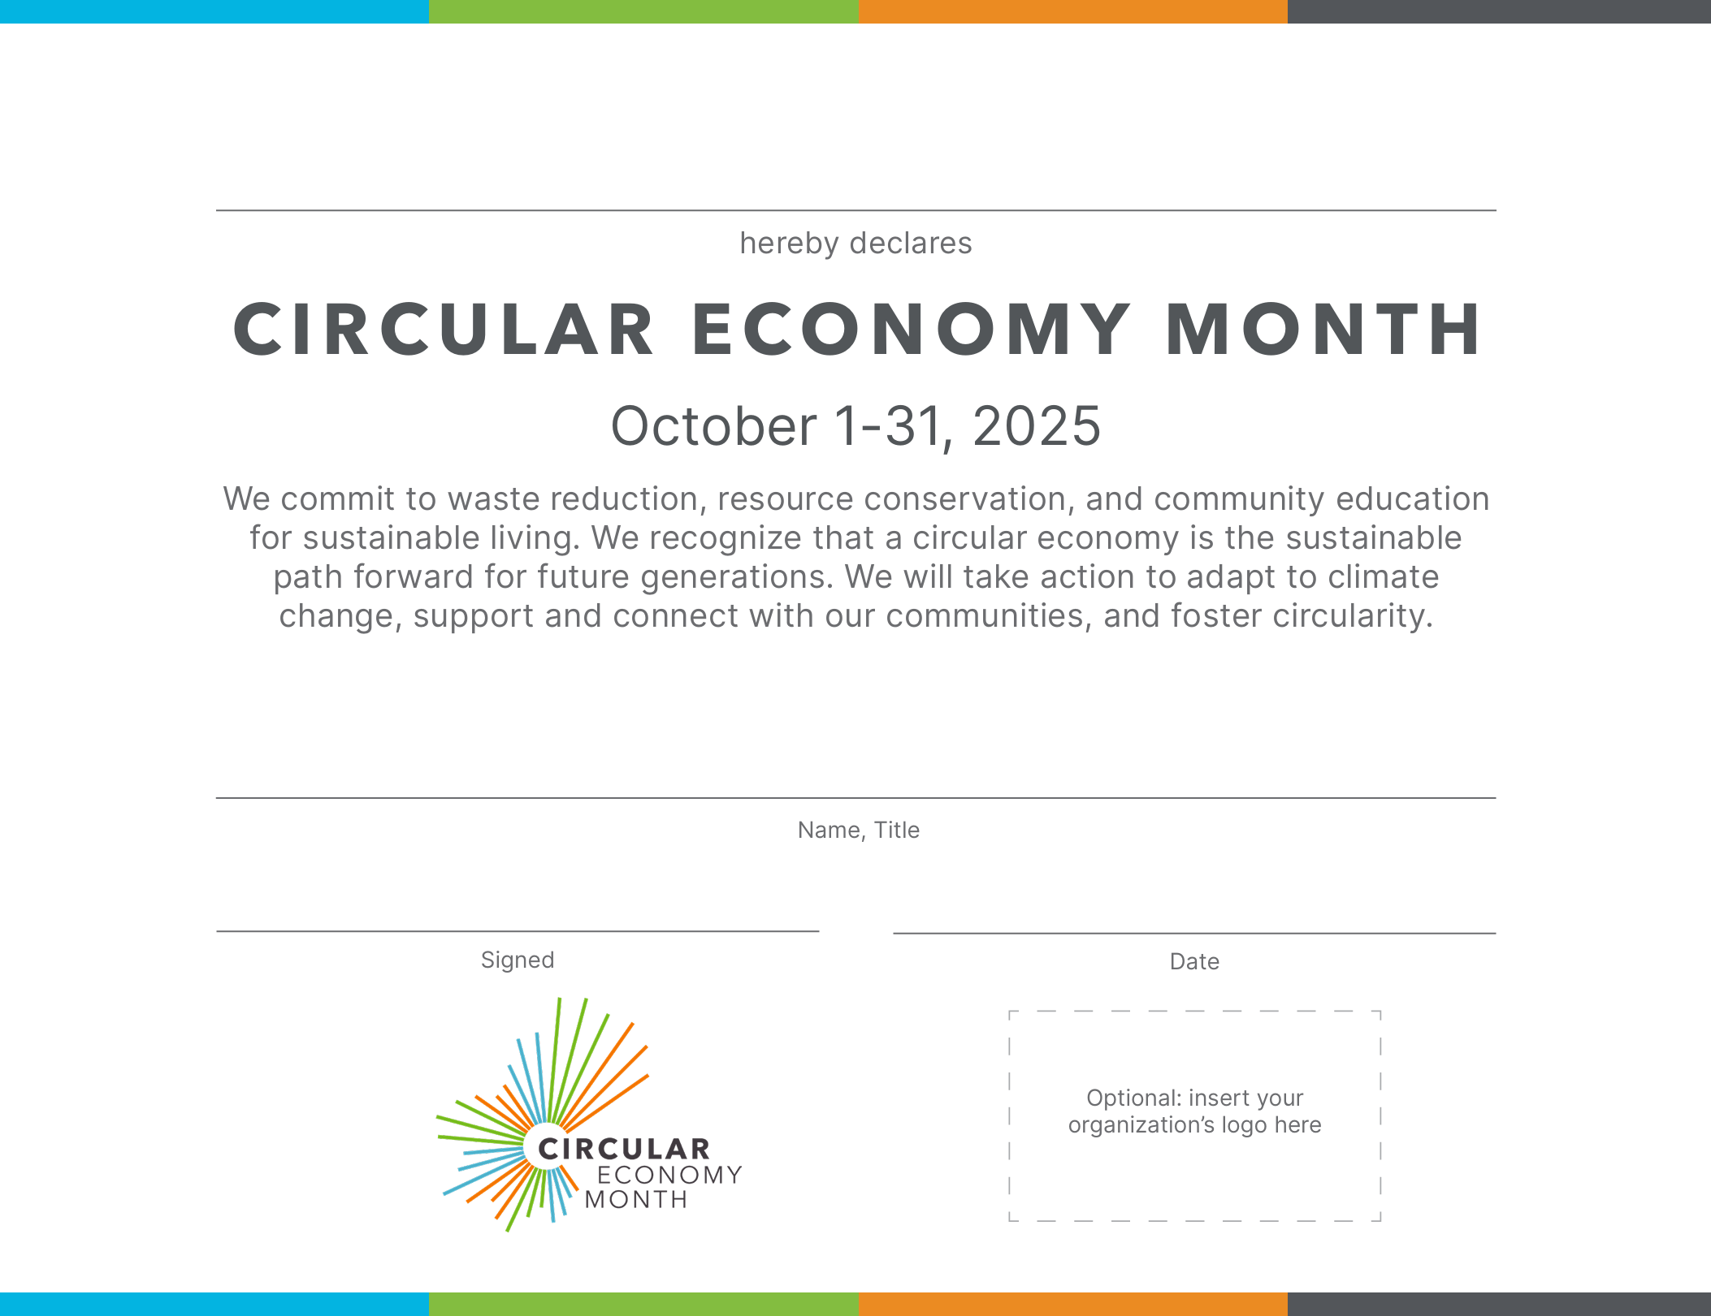
October 1-31, 2026
Replace this text box with an image of your organization’s logo; if no logo, delete this text box.
Enter the date of signing
Enter your name and title
Enter your organization’s name

